V-Electronics: Revolutionizing Smart Device Management

**Phase 4: Process Automation (Admin)**

Once the data model was defined in Phase 3, the next step in the **V-Electronics Salesforce Project** was to automate routine processes. Salesforce provides powerful declarative (point-and-click) tools for automation, allowing businesses to improve efficiency, reduce manual errors, and streamline workflows without heavy coding.

This phase focused on applying rules, flows, and automation features to ensure that data captured in the system was acted upon consistently and accurately.

**1. Introduction**

Automation is at the heart of Salesforce’s value proposition. For V-Electronics, this meant automating tasks such as order approvals, warranty tracking, notifications, and customer follow-ups. By configuring automation tools, the project ensured that sales agents, managers, and customers experienced a **smooth and proactive system** instead of relying on manual processes.

**2. Objectives of this Phase**

* To enforce data quality through validation rules.
* To eliminate repetitive tasks using workflow rules and process builder.
* To set up approval processes for order management.
* To implement Salesforce Flows for advanced automation and guided user experiences.
* To notify stakeholders automatically via email, tasks, or custom notifications.

**3. Detailed Description of Contents**

**Validation Rules**

* Ensured data accuracy before saving records.
* Example Rules:
  + Warranty period must be greater than 0.
  + Order amount cannot be negative.
  + Customer email must follow a valid format.
* Benefit: Prevented incorrect or incomplete data from entering the system.

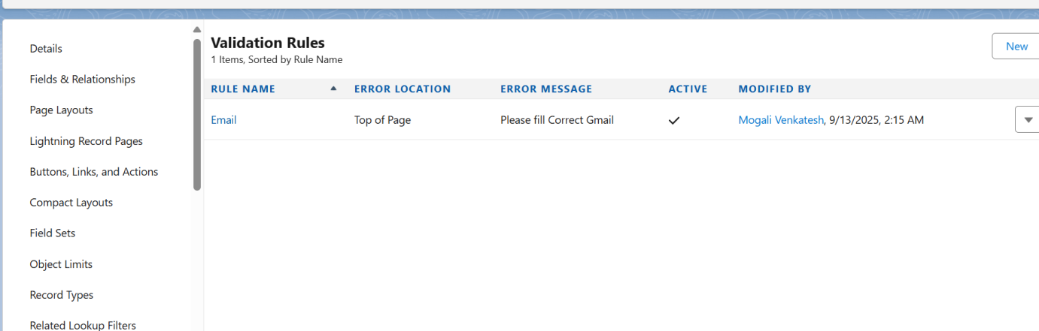

**Workflow Rules**

* Implemented simple, criteria-based automation.
* Example: When an order was marked “Completed,” the system automatically sent a “Thank You” email to the customer.
* Example: When a product stock dropped below threshold, a task was assigned to the inventory team.

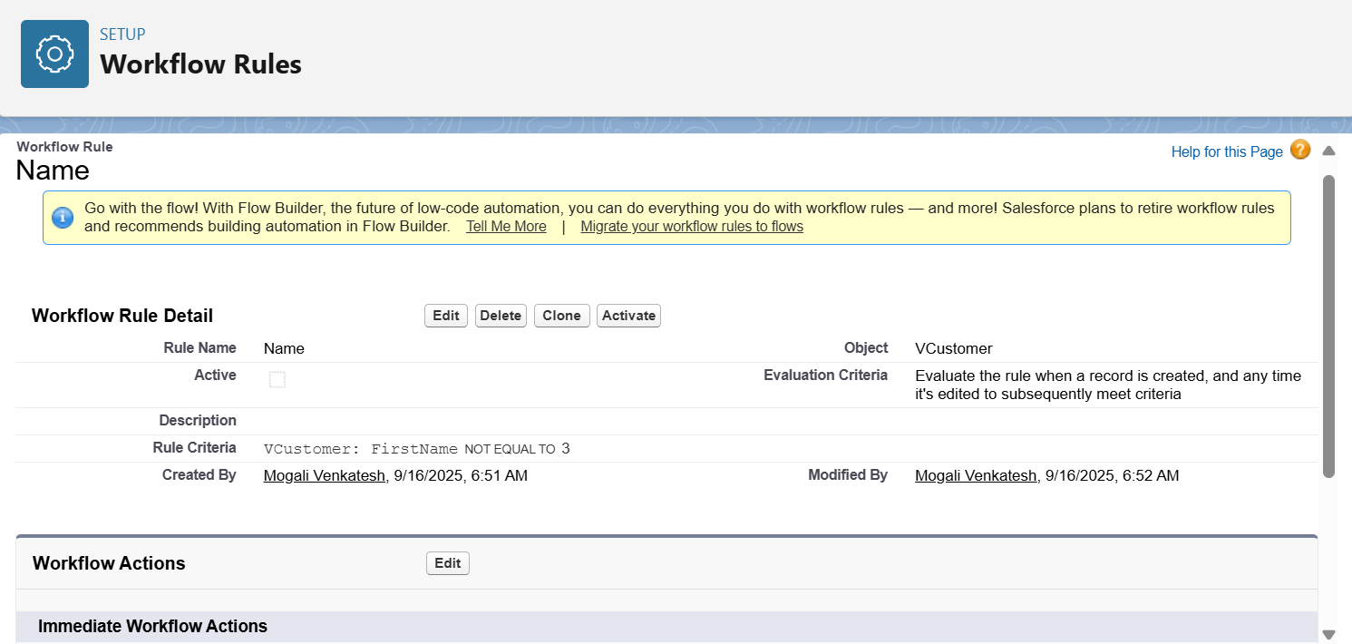

**Process Builder**

* Designed more complex, multi-step automation processes.
* Example: On creating a new VIP customer (Loyalty Tier = Platinum), the system updated their record, assigned them to a dedicated account manager, and sent both an internal notification and a welcome email.
* Benefit: Consolidated multiple workflow rules into one structured process.

**Approval Process**

* Built structured approval flows for sensitive operations.
* Example: Orders with discounts greater than 20% required approval from a Sales Manager before confirmation.
* Benefit: Introduced control and accountability for business-critical decisions.

**Flow Builder**

* Used extensively to handle advanced automations:
  + **Screen Flows:** Guided sales agents through customer onboarding with step-by-step forms.
  + **Record-Triggered Flows:** Automatically updated warranty status when product service cases were resolved.
  + **Scheduled Flows:** Sent weekly reports to managers every Monday morning.
  + **Auto-launched Flows:** Integrated background operations, such as updating loyalty points after each purchase.

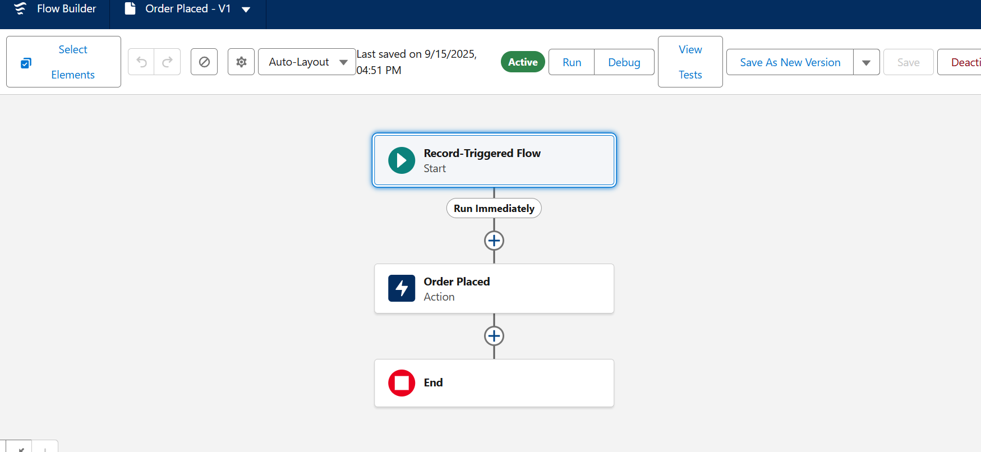

**Email Alerts**

* Configured automated email templates and notifications.
* Example: Customers received order confirmation emails with product and delivery details.

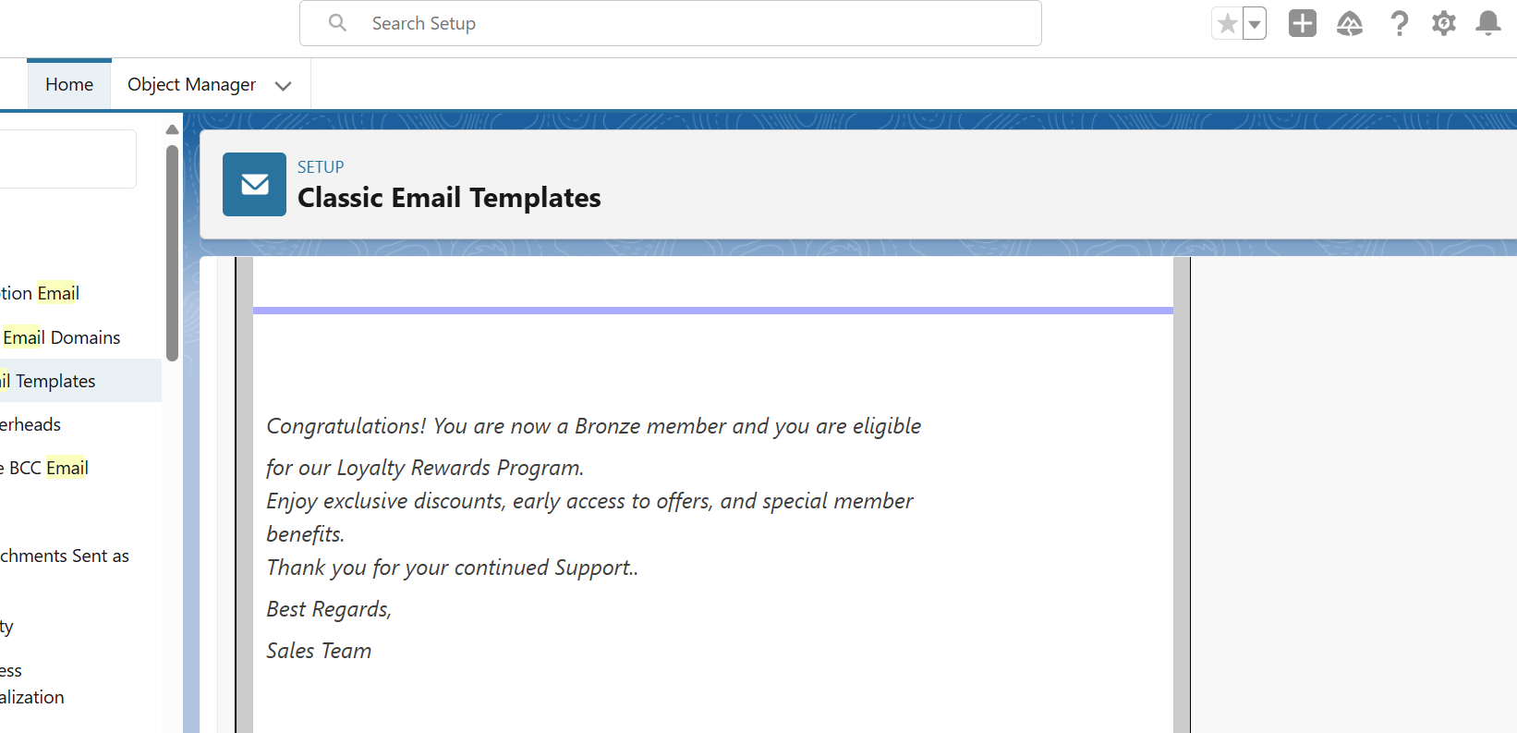

**Field Updates**

* Automated updates to fields when certain conditions were met.
* Example: If the order payment status was updated to “Paid,” the related field on the customer record reflected “Active Customer.”

**Tasks**

* Assigned tasks automatically to relevant team members.
* Example: When a high-value customer was added, a follow-up task was created for the sales agent to schedule a welcome call.

**Custom Notifications**

* Configured Salesforce’s notification system for urgent alerts.
* Example: Managers received push notifications when a bulk order worth more than ₹1,00,000 was created.
* Benefit: Allowed real-time awareness on mobile and desktop.

**4. Deliverables/Outcomes of Phase 4**

* Enforced data accuracy with validation rules.
* Implemented workflow rules and process builder automations.
* Built approval processes for discounts and order approvals.
* Designed multiple flows (screen, scheduled, auto-launched, and record-triggered).
* Configured email alerts, field updates, tasks, and notifications.

**5. Conclusion**

Phase 4 introduced **intelligent automation** into the V-Electronics Salesforce system. By combining declarative tools like flows, process builder, and approval processes, the project minimized manual workload and ensured consistent execution of business rules.

This created a proactive system that supported sales teams and improved customer satisfaction. With automation in place, the project moved naturally into **Phase 5 (Apex Programming)**, where custom code would address advanced business requirements beyond declarative capabilities.